ANAGHA ACHARYA

1BM19CS224

LAB1- INSURANCE DATABASE

PERSON: CAR: ACCIDENT:

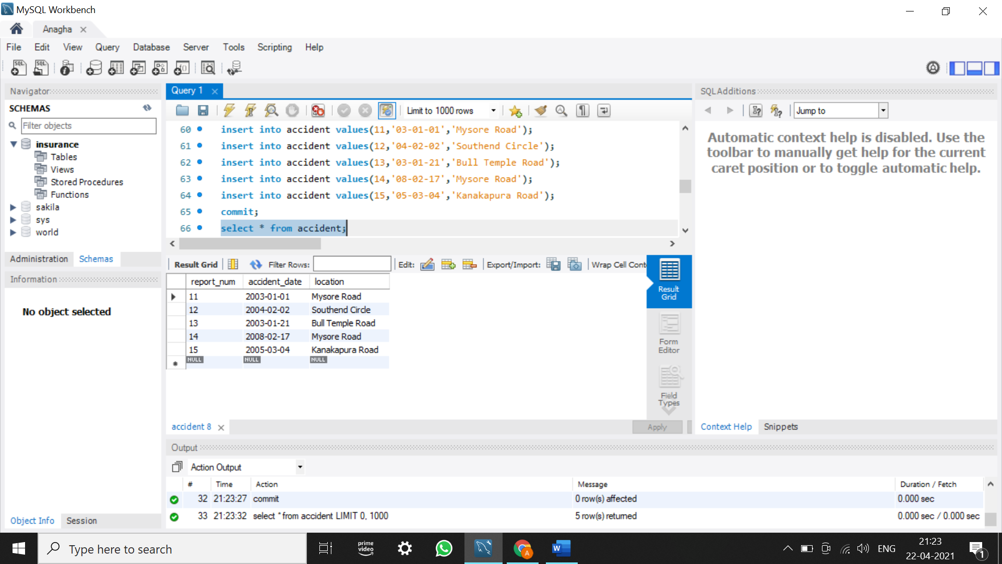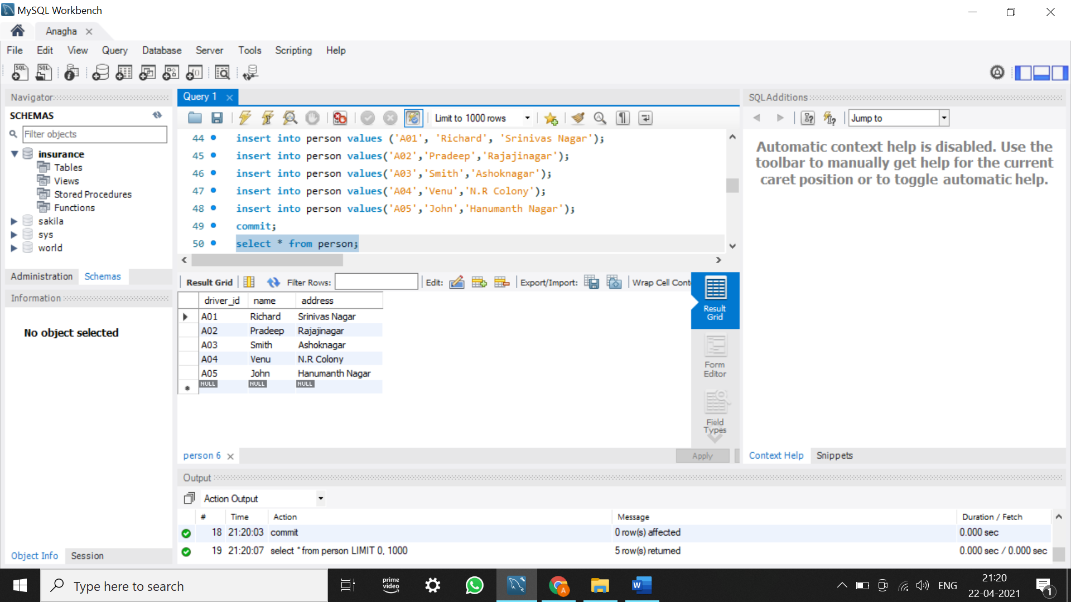 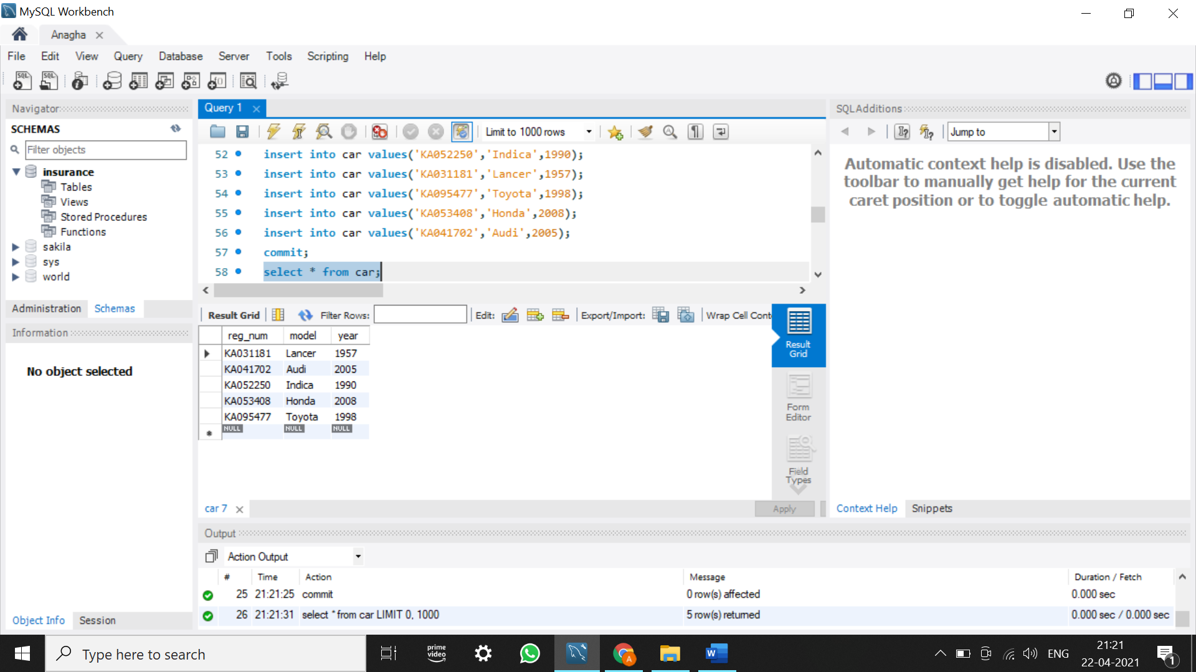

OWNS: PARTICIPATED:

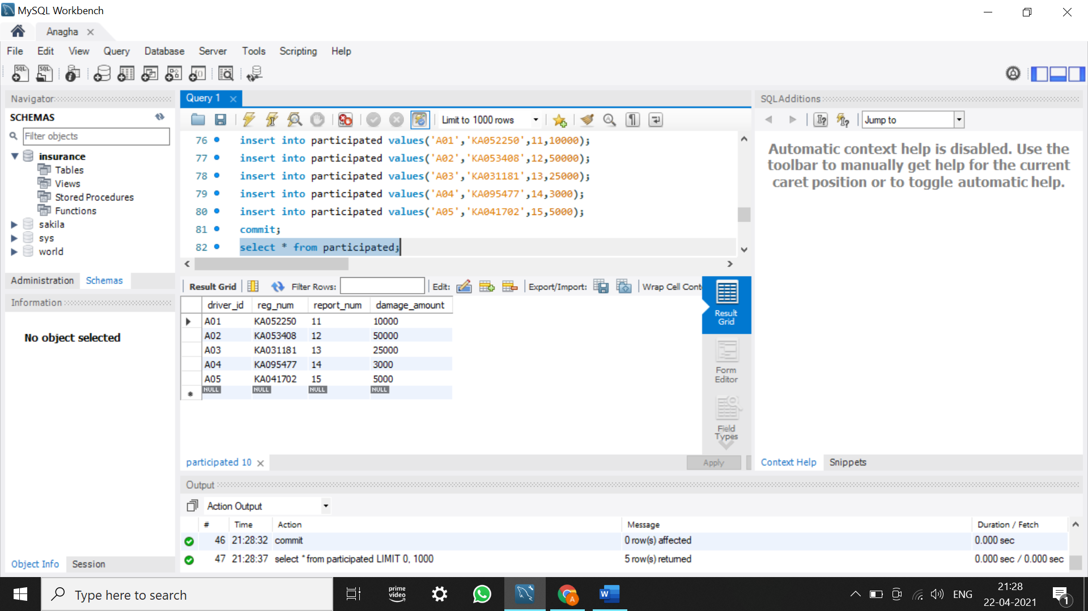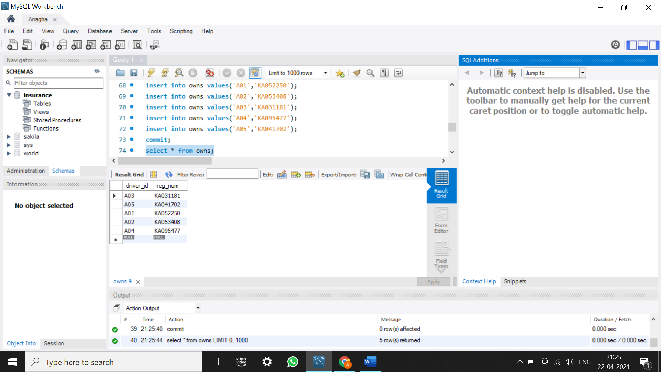

UPDATED PARTCIPATED:

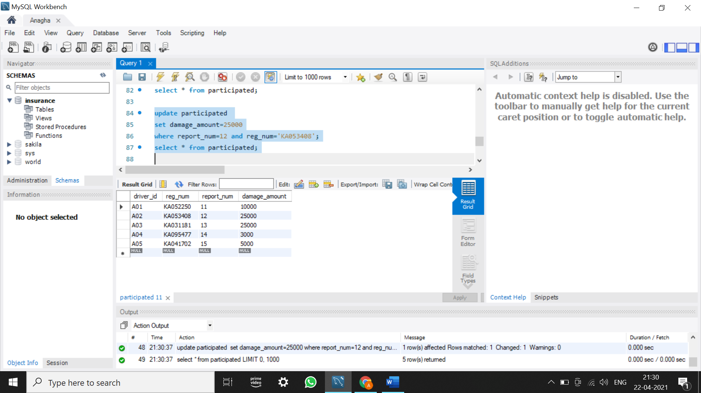

NEW PERSON: NEW CAR: NEW ACCIDENT:

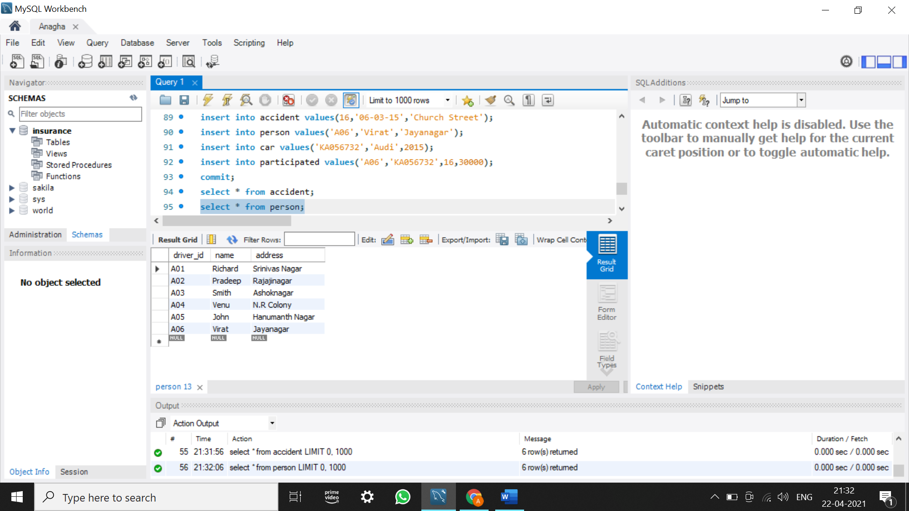 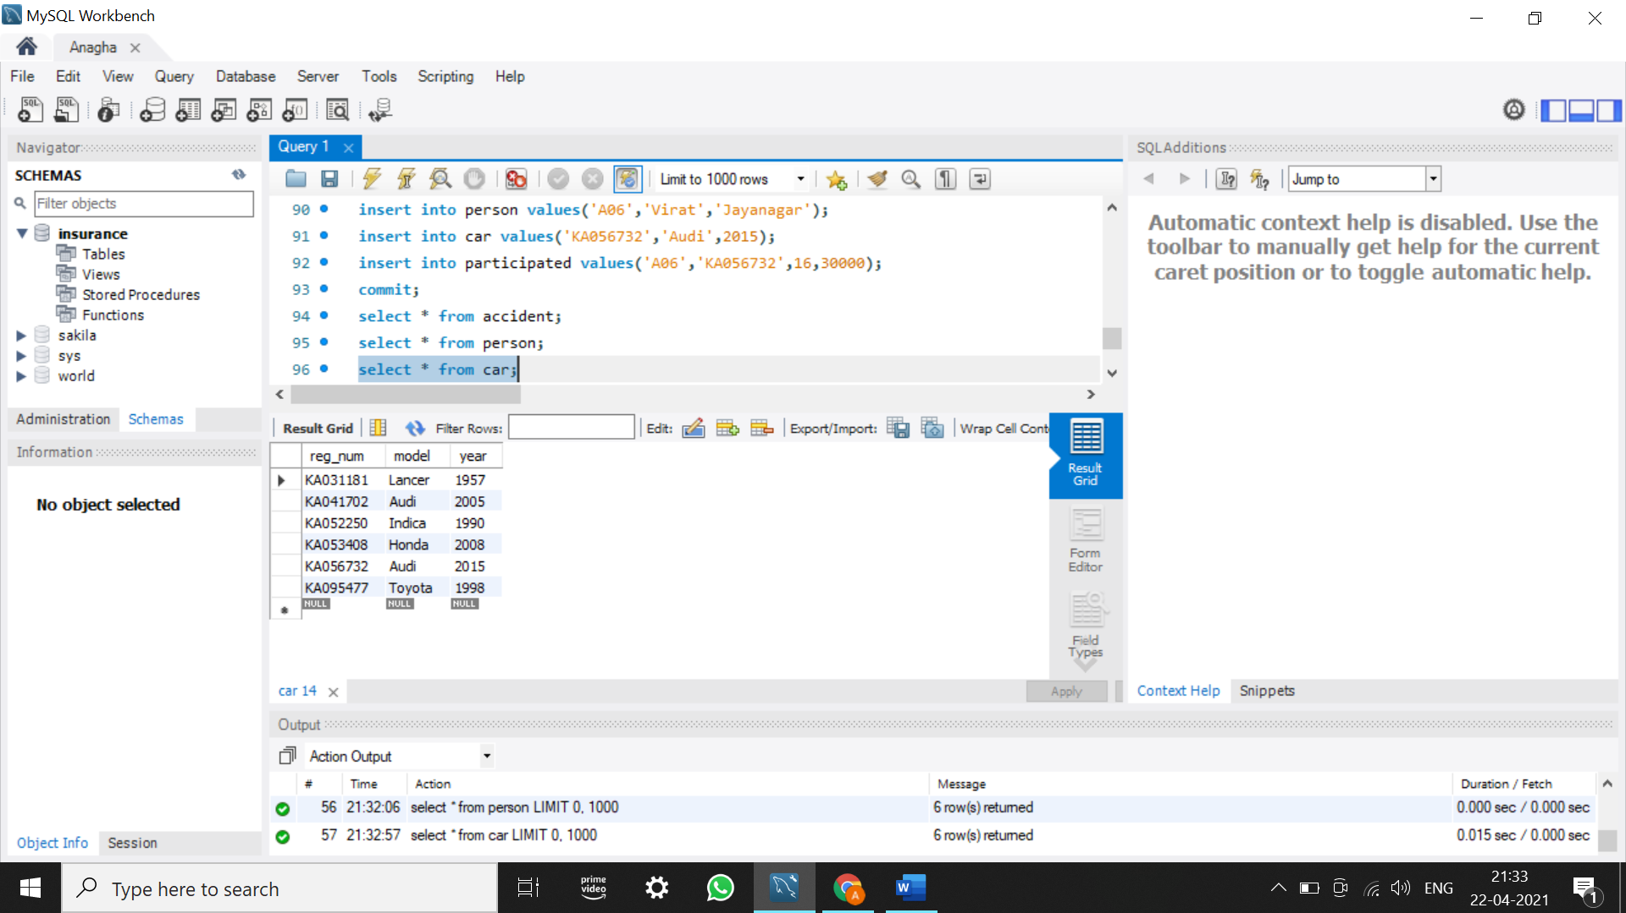 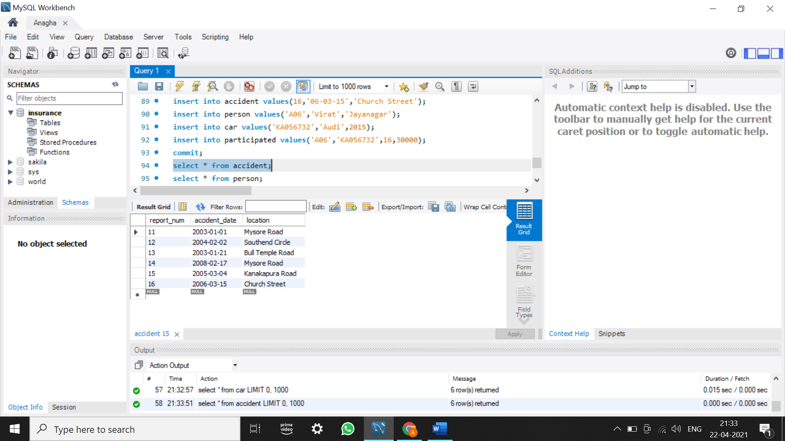

NEW OWNS: NEW PARTICIPATED:

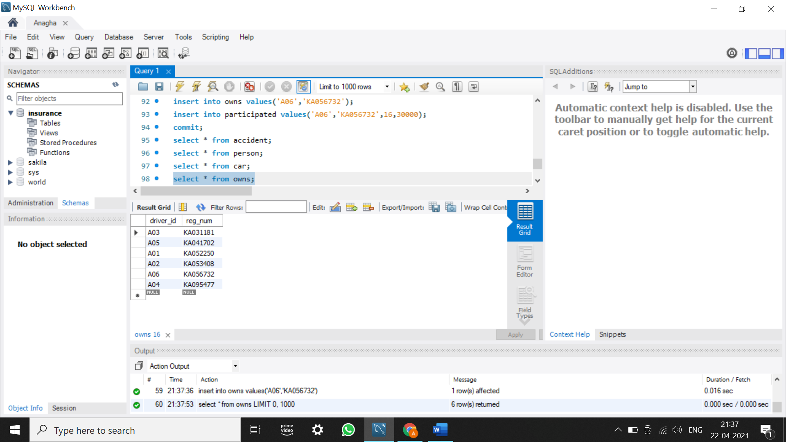 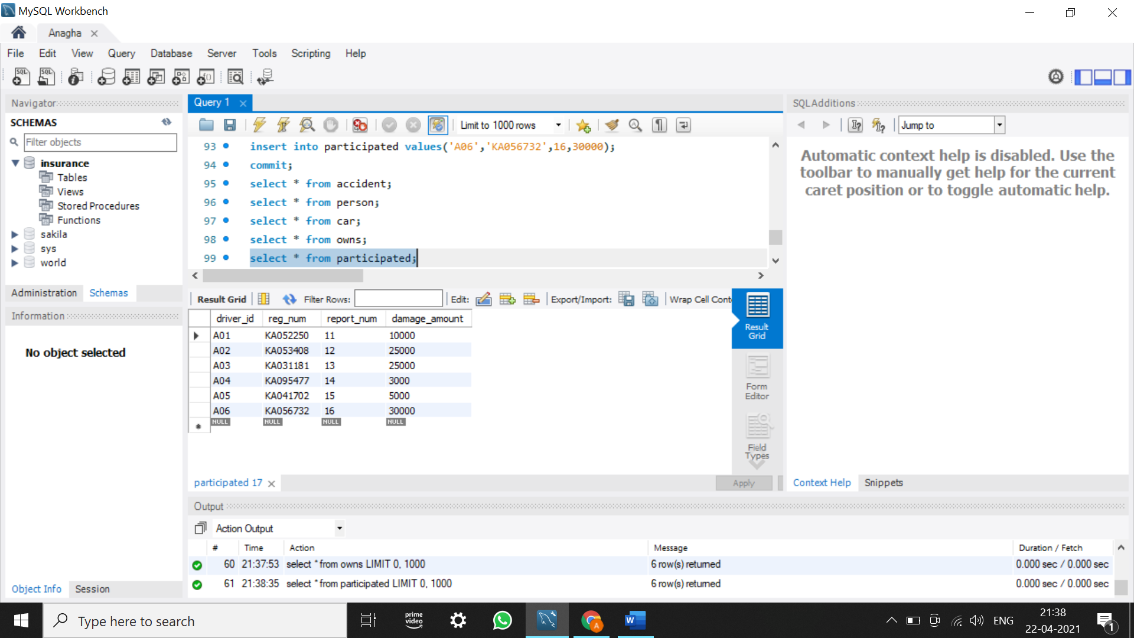

NUMBER OF ACCIDENTS IN 2008: NUMBER OF CARS OF MODEL ‘AUDI’:

